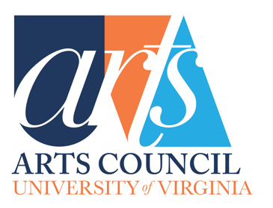
Arts Council Grant Report
This form needs to be filled out if you received an Arts Council grant in the last year and are proposing a new grant for your department/program. Your new proposal will not be considered if it is not accompanied by this report. If your department/program did not receive a grant last year, you do not need to fill this form out.

Date:
Contact Name & Title:
Contact Email:
Department:
Title of Grant:

Type of Proposal (publication, performance, artist-in-residence, exhibition):

Total Cost of Project:

Total Awarded from UVA Arts Council:

Is the project complete?

If the project is not complete, please explain (boxes will expand as needed) (250-word limit):
Please note: this form will need to be completed, in full, upon the completion of the project.

Describe student impact, including the number of students this project reached (150-word limit):

Describe the community impact, if applicable (150-word limit):

According to the metrics established in the grant request, was this event successful? (150-word limit):

ADDENDUMS: Please attach supporting photos or documents that were affiliated with your project (photos, promotional publications, programs, recordings, videos, or articles about the event). Please include examples of materials related to the grant that included the Arts Council Logo and acknowledging phrases.

