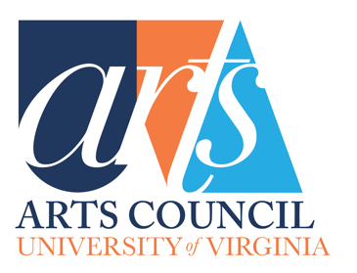
Arts Council Grant Proposal Form
This form needs to be filled out fully in order for your submission for an Arts Council grant to be considered. If your school, department or program received an Arts Council grant last year, you will also need to include the Arts Council Grant Report.

Date:
Contact Name & Title:
Contact Email:
Department:
Title of Proposal:
Type of Proposal (publication, performance, artist-in-residence, exhibition):

Project Date(s) & Venue:
Total Cost of Project:

Total Requested from UVA Arts Council:

Other sources of funding secured (boxes will expand as needed):

Other sources of funding pending:

Goals of Project (150-word limit):

Brief Project Description (250-word limit) - detailed Report can be attached below; optional 2-minute video pitch

Describe student impact, including estimated number of students it will reach (150-word limit):

Describe the community impact, if applicable (150-word limit):

Impact Beyond UVA, if applicable - How would this promote the University of Virginia to the state, our country, and internationally? (150-word limit)

What metrics will you use to measure the project’s success? (150-word limit)

Attachments:

Itemized Budget - Please complete and attach the Arts Council Budget Form

Detailed Description: You are welcome to attach a detailed description of the project, include any letters of support from colleagues, and any supporting photos or documents or recordings or videos that you think will better explain your proposal.

Optional Video Pitch: In addition to the Arts Council Grant Proposal Form and the Detailed Description, you are welcome to provide a 2-minute video pitching the proposed project.

Grant Report: if applicable. If the Arts Council funded a project for the current academic year, please provide an Arts Council Grant Report
…………………………………..
In the event you are a grant recipient please provide information for disbursement of the award:

☐ Via a Rector and Visitors Account: Provide a GL String #

☐ Via UVA Fund Account #

☐ Via paper check:

Payee Name:

☐ Pick up at Alumni Hall
☐ Messenger Mail to Box
☐ USPS mail – enter address below:

Please contact Emma Terry, Programs & Communication Director for UVA Arts, with any questions at emma@virginia.edu

