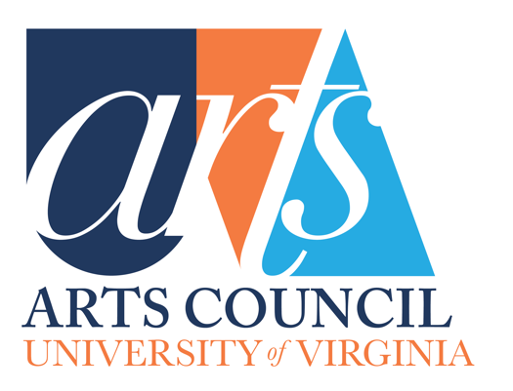

Guidelines for UVA Arts Council
Grants Applicants

Guidelines for Grant Applicants – Contents

- Goals of the UVA Arts Council Grants Committee
- Values
- Guidelines for Grant Applicants
- Requirements of Applicants and Grant Recipients
  - Application Deadline
  - Complete Proposal Form
  - Complete the Budget Form: Must accompany the Proposal
  - Arts Council Grant Report Form
- What is Funded and What is Not Funded
- Grant Administration
- When Project cannot be Done as proposed and approved
- Acknowledging the Arts Council
- Appendix
  - UVA Arts Council Logos

Separate Attachments
  - Arts Council Grant Proposal Form
  - Budget Form
  - Arts Council Grant Report

Goals of the UVA Arts Council Grants Committee

- Promote and increase the visibility and influence of the arts on Grounds at UVA.
- Encourage innovation in the arts at UVA.
- Promote direct impact on and higher participation of UVA undergraduates in the arts at UVA, in both breadth and depth.
- Promote visibility and engagement of arts at UVA in the university community at large, in the wider community, regionally, nationally, and internationally.
- Support established ongoing arts programs that promote the Arts Council and that have high participation and visibility on Grounds and beyond.
- Highlight the commitment and high quality of the arts at UVA and the students at UVA to the wider performing and fine arts communities and professionals outside UVA.
- Offer opportunities for professionals in arts-related fields outside of UVA to experience the strong commitment and high quality of the arts at UVA and the students at the University.

Values: The Grants Committee statement of values promotes the Arts Council’s Mission and Goals and expresses the general criteria and priorities that guide its grants decisions.

- Innovation: Pilot projects; trial initiatives, start-up, and early-stage endeavors.
- Diversity, Equity, and Inclusion: Projects that engage the diversity of UVA and the community and reach out to new and diverse artists and audiences.
- Focus on Undergraduate experience of and participation in the arts at UVA.
- High impact: Maximize participation and impact on number of students and overall community participation in the arts within one year.
- Provide multiple formats or levels of impact (online platforms, forums, venues) for participation in the arts by students, community members and guest participants (some combination of artists’ residencies, master classes, concerts, lectures, readings, performances…).
- Outside influences: Guest Residencies/visiting guests, by recognized professionals and artists brought to UVA where they can have high student and community impact as well as experiencing the quality of the arts and the students at UVA.
- High Visibility at UVA and Beyond: Projects that bring high visibility/recognition to the arts at UVA and beyond.

Guidelines for Grants Applicants
- Proposals should be for projects that are specific and substantive, and should explain the project’s impact on students, as well as, if applicable, its impact on the UVA community at large, the wider community in Charlottesville, and beyond.

- Review the Goals and Values/Criteria of the Grants Committee, above. Your proposal does not need to meet every goal and value to be considered for funding, but the goals and descriptions presented in each proposal should bear some relationship to the Committee’s goals and values.

Requirements of Applicants and Grant Recipients
- Application Deadline: Applications for grants should be received by the posted deadline, usually one month in advance of a full Council meeting, to give the Committee time to research each project and make recommendations.
- Complete Proposal Form: The Arts Council Grant Proposal form (see appendix for template) needs to be filled out fully in order for a submission for an Arts Council grant to be considered. If your department or program received an Arts Council grant the previous year, you will also need to include the Arts Council Grant Report. NOTE: There is an option to attach to the proposal form two additional files in the support of a proposal:

  - Detailed Description: Applicants are welcome to attach a detailed description of the project, include any letters of support from colleagues, and any supporting photos or documents or recordings or videos that you think will better explain your proposal.
  - Optional Video Pitch: In addition to the Brief Description and the Detailed Description, you are welcome to provide a 2-minute video pitching the proposed project.

- Complete the Budget Form: The UVA Arts Council Budget Form must accompany the proposal (see appendix for template). If the Grant Proposal requests that UVA Arts Council provide 20% or more of the funds for a proposal, please fill in this Budget Form with your best estimates. (We also welcome budgets, if available, for which UVA Arts Council would be funding less than 20% of the budget).

- Arts Council Grant Report Form
  - If your department or program received an Arts Council grant the previous year, you will also need to include the Arts Council Grant Report (see appendix for template). Applications submitted without the Arts Council Grant Report (if required) will not be considered for continued support in the upcoming cycle.
  - By accepting Arts Council funds, you agree to provide the Arts Council, via the Vice Provost for the Arts office, with an Arts Council Grant Report, including relevant photos, prior to submitting a new grant request or directly following the completion of your project, if it extends past the Arts Council Grant Proposal Deadline.
What is Funded and What is Not Funded

Please look over the UVA Arts Council Budget Form.
This Budget Form serves two purposes. One is to give grant applicants some insight into the types of projects and aspects of projects that the UVA Arts Council considers for funding. Second is to clarify for the Arts Council where the funds will be used. Although we welcome itemized amounts, we understand that those amounts may not be available in all categories at the time the Grant Proposal is submitted. We are looking for the best estimates and some categories may not apply to your proposal. There is a category for "Other" items that may be unique to your project.

- Funding amounts: UVA Arts Council grants may be offered up to $10,000.

- When Grant monies are awarded
  - Funding decisions are dependent upon the monies available in a given year. Lower ranked but approved proposals for which funds are not immediately available may be funded later in the year if monies become available by June 30th. Any money collected after that goes into the next granting cycle.
  - Please note that the Arts Council Annual Fund Grants are not to be considered part of any department’s budget. Projects that are successful and have been funded for consecutive years may be encouraged to also seek other more predictable funding.

- Length of Grants-Timeline Guidelines
  - We do fund projects for a single year timeline. Grant applications should be made for projects to be completed in one year.
  - We do not fund multi-year timelines when subsequent year budgets are unknown.
  - We do not fund projects within the fiscal year that the proposal is submitted.
- Travel Funding Guidelines
  - We give preference to bringing experts in their arts-related field to UVA where they can have high student and community impact.
  - We are less likely to fund sending a small group from UVA to another location, but this can vary based on the project.
- Formats
We are open to a variety of formats that impact the arts on Grounds. This list is only a guide and formats considered are not limited to this list.
  - We do consider funding performances and exhibitions through visual art, music, dance, drama, media arts, architecture, or multi-disciplinary arts.
  - We do consider funding conferences or panels or lectures or classes that engage students and the community.
  - We do consider funding projects and programs using emerging technology in the arts with online presence, including content and accessibility to students and beyond.

- Equipment/“Bricks & Mortar” type proposals
  - We do fund capital expenses tied to other objectives (tied to objectives that expand access or programs). Example: replacing the Foundry.
  - We will take equipment needs under consideration contingent on immediate needs or impact on students. All equipment funded remains the property of the University of Virginia.
  - We do not fund straightforward capital improvements.
- Compensation/wages/Honorariums/ Speakers’ fees
  - We do fund guests such as Artists-in-Residence and Speakers Fees.
  - We do not fund salaries for existing positions due to budget issues or new positions denied in the University budgeting process.

Grant Administration
Please contact Emma Terry, Programs & Communication Director for UVA Arts, with any questions at emma@virginia.edu .

When Project cannot be done as proposed and approved
If a project cannot be carried out or completed or needs to be modified or did not receive funds from other sources as expected, it is the responsibility of the department to contact the UVA Arts Administration Staff so that appropriate steps can be taken for approval of modifications by the Council or for return of funds.
- Modifying a Grant after Approval: If a project cannot be done as proposed and approved, the Committee will accept formal proposals to modify or clarify any changes and will consider approving funding for the project as modified.
- Return of Grant Funds: If the project cannot be started or only partially completed as approved, and modification is not possible, funds need to be returned.
- No carry-over of funds: Grant funds cannot be carried over until the next year. Rather the funds must be returned, and a grant proposal resubmitted for the next academic year.

Acknowledging The Arts Council
- Include Logo: Please be sure to include the Arts Council logo in your publications (whatever the media) related to any Art Council funded projects (copy from below or contact Emma Terry for a higher-resolution or black & white.) Logo images provided at the end of this document. (see appendix for logo images)

- Printed Materials: The Arts Council contribution should be recognized in any printed materials (programs, CD liner notes, exhibition posters, etc.) resulting from grants.
- Wholly Funded Projects: For projects wholly supported by an Arts Council grant, the phrase underwritten by the University of Virginia Arts Council is suggested.
- Partially Funded Projects: For partial funding, use the phrase supported by the University of Virginia Arts Council.

- Project Updates: Grant recipients are encouraged to send updates throughout the academic year highlighting events related to the projects in the form of videos, photos, testimonials from participants, promotional materials, etc.

- Grant Reports: Please include examples of materials related to the grant that included the Arts Council logo and acknowledging phases.

Appendix #1: UVA Arts Logo Images

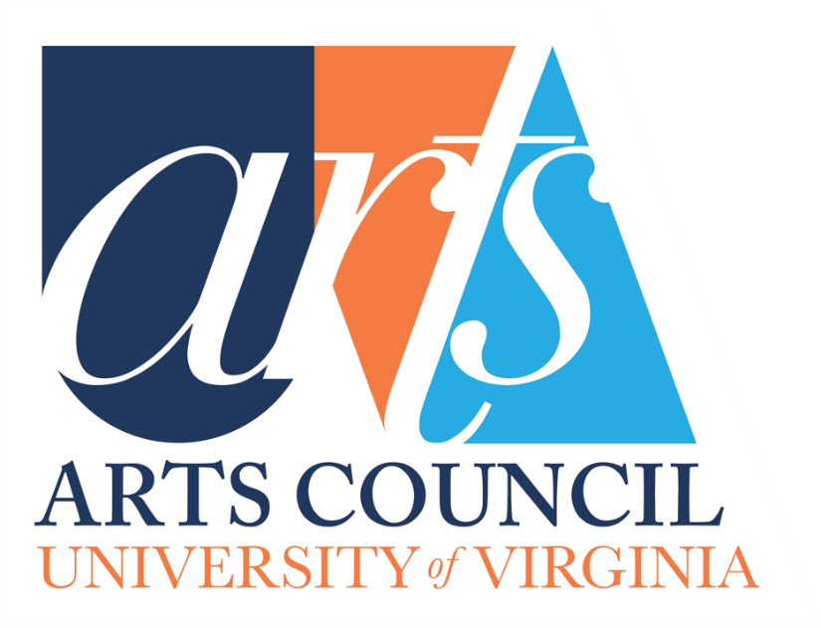

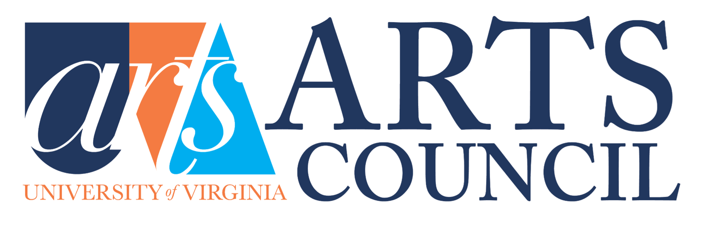

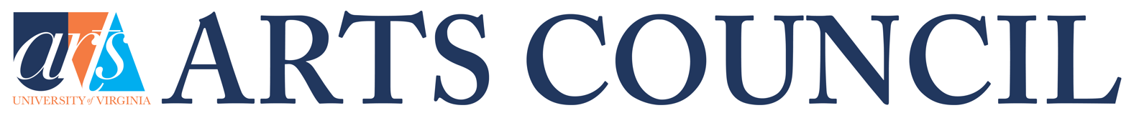

FULL Arts Council Logo Suite: https://flic.kr/s/aHBqjAYUDD

