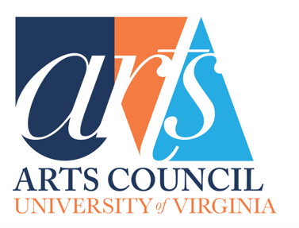
UVA Arts Council
Grant Proposal Form

Arts Council Grant Proposal Form - 2024-2025
This form needs to be filled out fully in order for your submission for an Arts Council grant to be considered.

Itemized Budget: Please complete the attached Arts Council Budget Form (attached in Appendix #3 below). Note that the funding requested needs to be for projects to be started and completed within the next fiscal year.

Detailed Description: You are welcome and encouraged to attach additional material related to this proposed project including a detailed description of the project, potential participants, any letters of support from colleagues, and any supporting photos or documents or recordings or videos that you think will better explain your proposal. Any additional materials will be reviewed by the Grants Committee. The briefer summary below helps distill the goals and potential impact for full council review. Detailed description attached: Yes _____ No _____
Optional Video Pitch: In addition to Brief Descriptions and Detailed Descriptions, you are welcome to provide a 2-minute video pitching the proposed project. Upload Link > Video submitted: Yes _____ No ____

Grant Report: If your school, department or program received an Arts Council grant last year, you will also need to include the Arts Council Grant Report. (attached separately).
Grant Report Form attached: Yes ______ No ______

Grants Committee Application Guidelines: Please review these guidelines (attached separately).

Arts Council Values: The Grants Committee statement of values promotes the Arts Council’s Mission and Goals and expresses the general criteria and priorities that guide its grants decisions.
- Innovation: Pilot projects; trial initiatives, start-up, and early-stage endeavors.
- Diversity, Equity, and Inclusion: Projects that engage the diversity of UVA and the community and reach out to new and diverse artists and audiences.

- Focus on Undergraduate experience of and participation in the arts at UVA.
- High impact: Maximize participation and impact on number of students and overall community participation in the arts within one year.
- Provide multiple formats or levels of impact (online platforms, forums, venues) for participation in the arts by students, community members and guest participants (some combination of artists’ residencies, master classes, concerts, lectures, readings, performances…).
- Outside influences: Guest Residencies/visiting guests, by recognized professionals and artists brought to UVA where they can have high student and community impact as well as experiencing the quality of the arts and the students at UVA.
- High Visibility at UVA and Beyond: Projects that bring high visibility/recognition to the arts at UVA and beyond.
Arts Council Grant Proposal Form - 2024-2025

Table cells will expand.
Department
Date
Contact Name & Title
Contact Email
Department
Title
Type of Proposal (publication, performance, artist-in-residence, exhibition…)
Project Dates(s) & Venue
Brief Description
(120-word limit): Detailed project description can be attached; optional 2-minute video pitch can also be attached or linked.
Total Cost of Project
Requested of Arts Council
Other Sources of Funding | Confirmed:  Pending:
Budget (please complete Form below Appendix #3)
Impact: Students and Community (120-word limit)
Impact Beyond UVA
(120-word limit)
Impacts linked to Arts Council Values
(120-word limit)

In the event you are a grant recipient, you must provide information for disbursement of the award on this application:
☐ Via a Rector and Visitors Account: UVA Worktags:
☐ Via UVA Fund Account #:
☐ Via paper check:
Payee Name:
☐ Pick up at Alumni Hall
☐ Messenger Mail to PO Box :
☐ USPS mail – enter address below:

Please contact Emma Terry, Programs & Communication Director for UVA Arts, with any questions at emma@virginia.edu

